2011-2012 PEIMS Data Standards
Section 6:
XML Diagrams

PEIMS 2011-2012 XML Data Standards
As of 03/01/2011
The legislature funded a project for the comprehensive rewrite of the PEIMS system, which includes the remediation of the 80-column punch-card format. The first part of the project was to replace the mainframe programs and it was completed on August 31, 2009. The agency has begun transitioning from the current 80 column record flat file data submission to an XML file format. Listed below is the transition time frame that will allow districts to begin sending data under the new XML format. A test pilot phase was introduced in the 2010-2011 collection year, where districts and charter schools could send in a test XML file and review error reports. Starting in 2011-2012 districts can send in either the production 80 column flat file or the new XML file layout, but each district must pilot at least one XML data submission during the 2011-2012 school year. See Appendix I for additional information on this requirement. Beginning with the 2012-2013 school year, every district and charter school will then be required to submit data under the new XML format starting with the 2012-2013 Fall / Midyear submission in October 2012 and TEA will no longer except the 80 column record layout.

File Naming Convension:
All XML files will be named with the industry standard ‘.XML’ extension.
The file name identifies the reporting entity and follows this naming convention:
- Minimum 11 characters
- Maximum 17 characters
Position | 1st | 2nd -5th | 6th-11th | 12th-14th (opt) | 15th-17th (opt) | File Extension
Description: | Collection Period  (F,M,S,E) | Four digits of school year | County-District Number | - Campus ID if campus data  - ‘000’ if partial data for district or ESC | Use as required to create unique name for partial file | .xml

Examples:
F2012227950.xml = 2011-2012 Fall Collection for Region XIII
F2012227901.xml = 2011-2012 Fall Collection for Austin ISD
F2012227901000BUD.xml = 2011-2012 Fall Collection for Austin ISD (partial file contains budget groups)
F2012227901002.xml = 2011-2012 Fall Collection for Austin High School (AISD)

PEIMS 2011-2012 and 2012-2013 XML Data Standards

2011-2012 – Districts may submit data using either an XML or 80 column flat file layouts. The XML validation edits will apply to the XML submissions and these files will not load unless the files pass the XML validations.

Requirements for 2011 – 2012 XML Pilot
In order to ensure that all districts and their software vendors are prepared to submit an accurate XML collection by the required date, all districts, open enrollment charter schools, and education service centers are required to successfully pilot at least one PEIMS file submission no later than August 31, 2012.
To pilot an XML data submission, the district must submit their XML file in parallel with their regular PEIMS file submission. For the purpose of the pilot, the XML will be used to generate reports for comparison purposes only. It will not be accepted in lieu of the district’s regular PEIMS submission. The approved PEIMS file for the Pilot will be the standard 80 character record file submitted by the district.
The Texas Education Agency strongly recommends that all districts review their pilot reports carefully to ensure that the XML file they submit will produce the same results as there 80 character file, and make use of the XML Checker Utility to review any errors. Districts and campuses that significantly customize their local software are especially encouraged to work closely with their software vendor to ensure that the XML file for each collection would yield the same results as their 80 character file.

2012-2013 – Districts must submit an XML layout file only. TEA will not accept 80 column flat file layouts.
Beginning with the 2012-2013 school year, all school districts, open enrollment charter schools, and education service centers will be required to submit all data to the Public Education Information Management System (PEIMS) via the approved XML schema documented in the PEIMS 2012-2013 Data Standards. The Edit+ system will no longer accept the 80 character records. The XML files must pass the XML validation edits in order to load to the EDIT+ application.

PEIMS Data and file Requirements
PEIMS Data and file Requirements

Rules for XML Schemas
School districts are permitted to submit Budget, Staff, Student and Actual data to TEA using the XML-based extract file process. The extract file process extracts information from district information systems and stores it in an XML-based file consistent with the XML Schema Definition (XSD) listed below.
The following business rules apply for XML schemas and the XSD validation process:
- The XML schema supports a number of built-in data types (e.g., date). When an XML element has a defined data type, a restriction is placed on the element content.
- The XML schema supports restrictions. In conjunction with the element’s declared data type, restrictions are used to control acceptable values for XML elements.
- Declared data types and restrictions enable the XSD validation process.
- The client-side XSD validation process is used to validate the XML file structure and data values against the schema definition.
- Every element within the XSD has a defined data type and one or more restrictions.
- PEIMS performs a client-side validation of the PEIMS extract file against the published PEIMS XSD.
- If the client-side validation fails, the file will not be transferred to TEA.

Each collection will be comprised of the Core Schema, Code Table Schema and the specific collection schema. For example the Fall collection will be built from the Core, Codes and Fall Schemas. The Core schema is comprised of complex types that are used in more than one collection and where all the and simple types are defined. The Code schema consists of all the Code table values.

diagram | 
complexType FallDistrict  diagram | 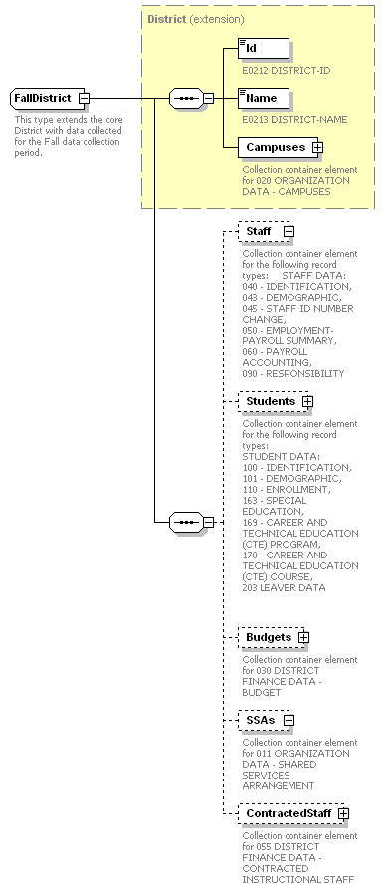

complexType CampusList
diagram | 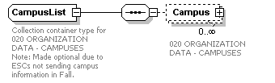

complexType Campus
diagram | 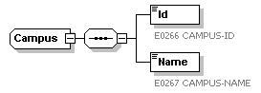

complexType StaffMemberList
diagram | 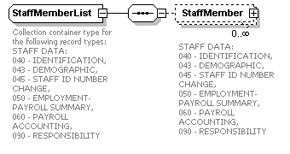

complexType FallStaffMember  diagram | 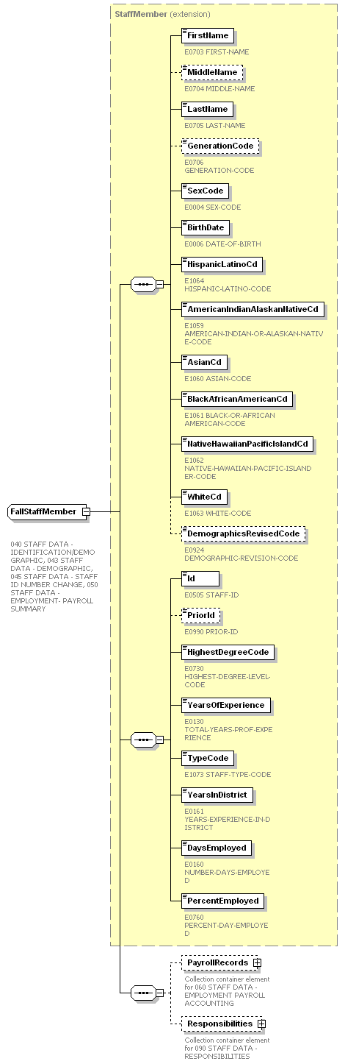

complexType PayrollEntryList
diagram | 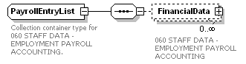

complexType PayrollFinancialData
diagram | 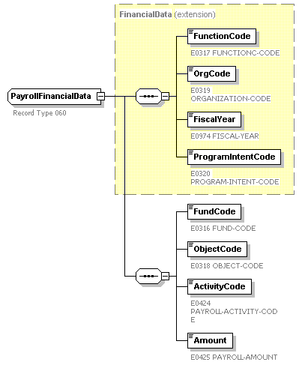

complexType StaffResponsibilityList
diagram | 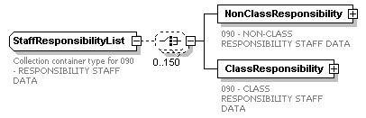

complexType StaffResponsibility
diagram | 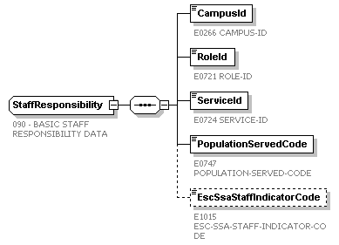

complexType StaffClassResponsibility
diagram | 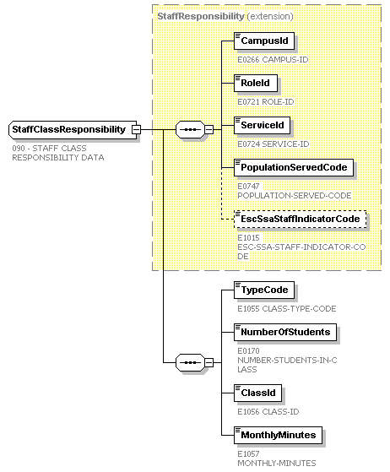

complexType StudentList
diagram | 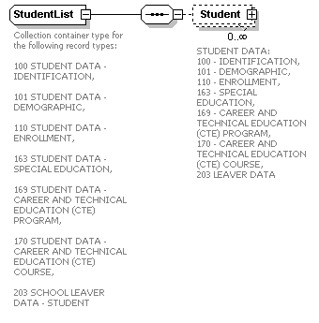
complexType FallStudent  diagram |  | 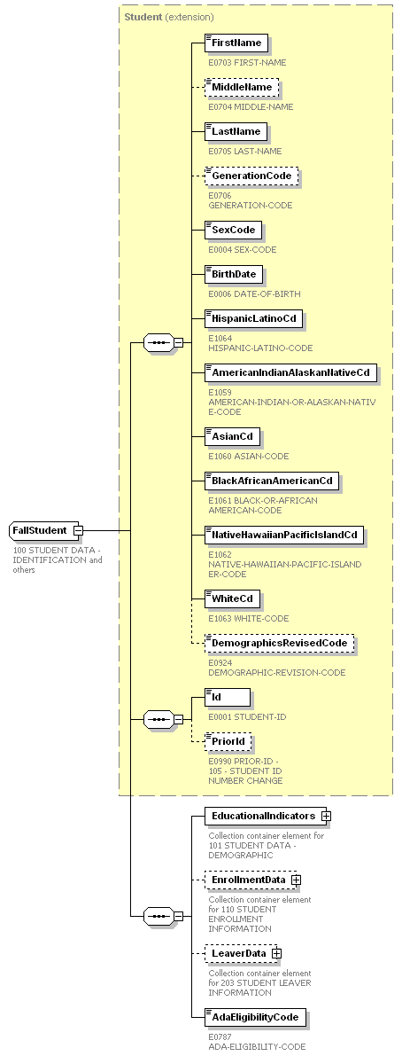

complexType EducationalIndicators
diagram | 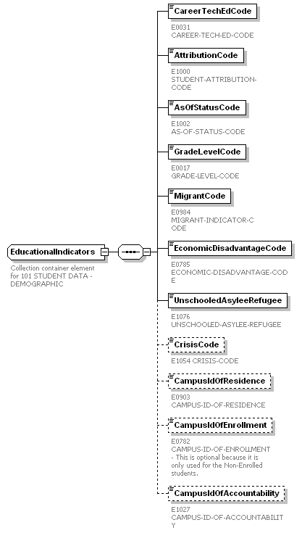
complexType Enrollment diagram | 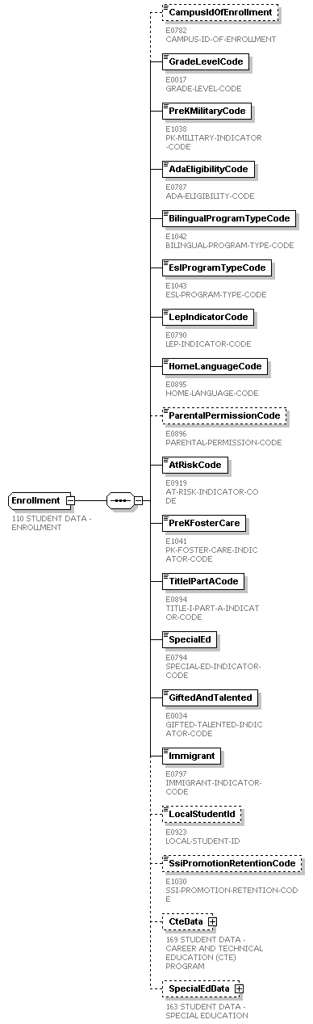

complexType CareerAndTechnicalEducation
diagram | 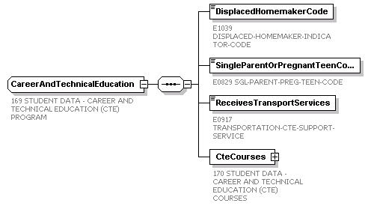

complexType ServiceList
diagram | 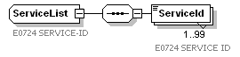

complexType SpecialEducation
diagram | 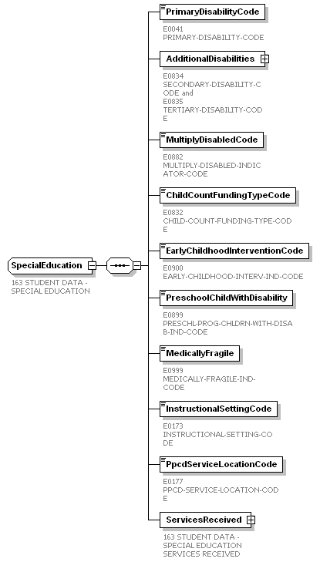

complexType DisabilityList
diagram | 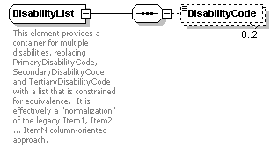

complexType SpecialEducationServices  diagram | 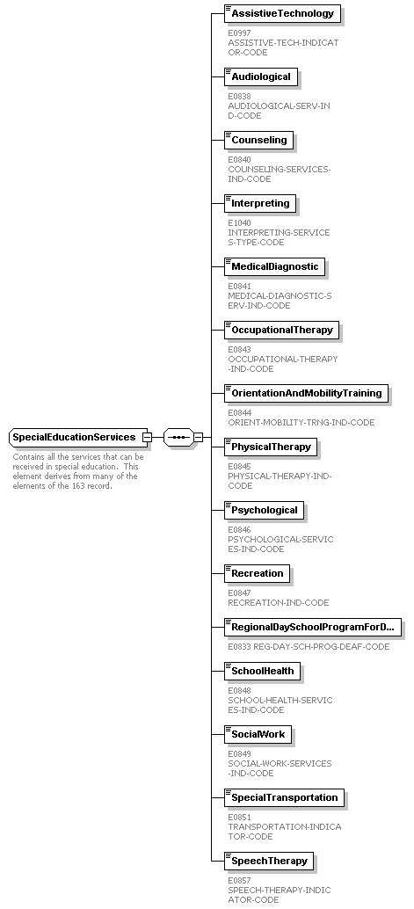
complexType Leaver
diagram | 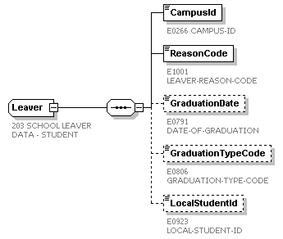

complexType BudgetList
diagram | 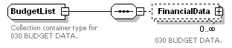

complexType BudgetFinancialData
diagram | 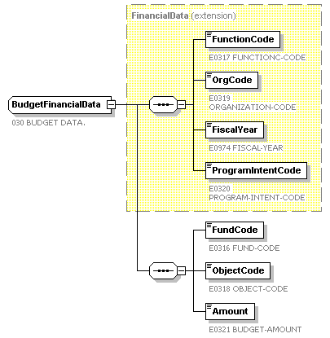

complexType SharedServiceArrangementList
diagram | 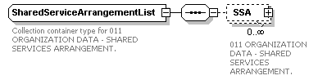

complexType SharedServiceArrangement
diagram | 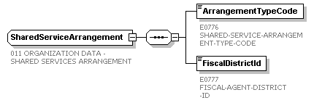

complexType FteSummaryList
diagram | 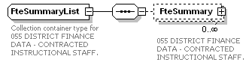

complexType FteSummary
diagram | 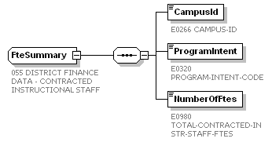

This page is intentionally left blank.
element MidyearDataSubmission
diagram | 

complexType MidyearDistrict
diagram | 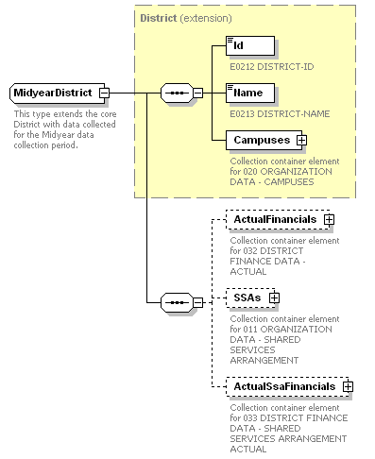

complexType CampusList
diagram

complexType Campus
diagram

complexType ActualFinancialDataList
diagram | 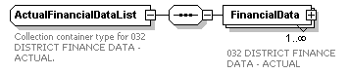

complexType ActualFinancialData
diagram | 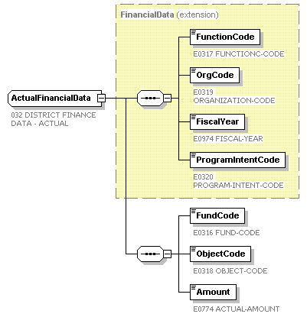

complexType SharedServiceArrangementList
diagram

complexType SharedServiceArrangement
diagram

complexType SsaFinancialDataList
diagram | 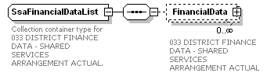

complexType SsaFinancialData
diagram | 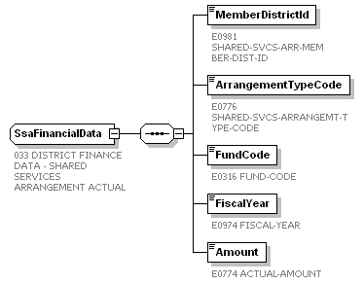

This page is intentionally left blank.
element SummerDataSubmission
diagram | 

complexType SummerDistrict  diagram | 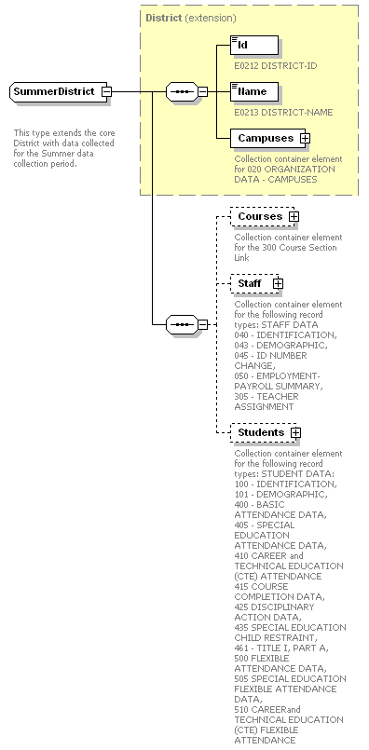

complexType CampusList
- diagram

complexType Campus
diagram

complexType CourseList
diagram | 

complexType Course
diagram | 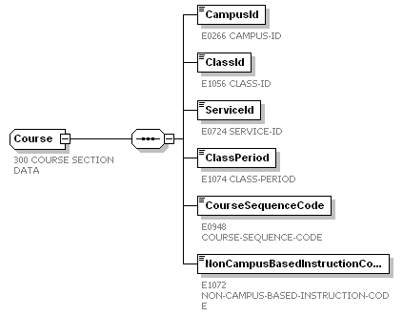

complexType StaffMemberList
diagram | 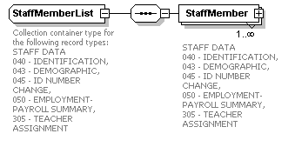

complexType SummerStaffMember  diagram | 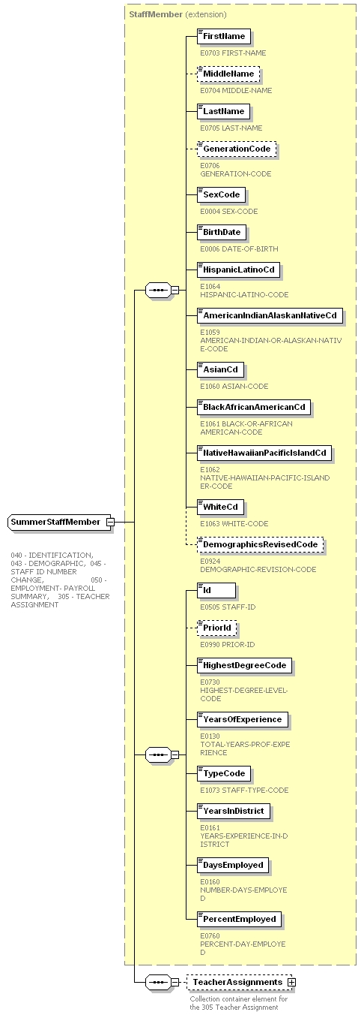

complexType TeacherAssignmentList
diagram | 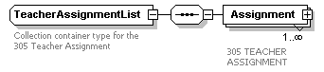

complexType TeacherAssignment
diagram | 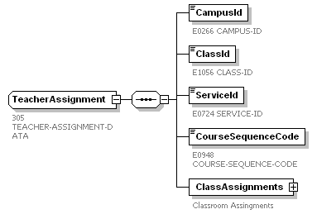

complexType ClassAssignmentList
diagram | 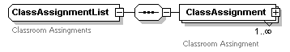

complexType ClassAssignment
diagram | 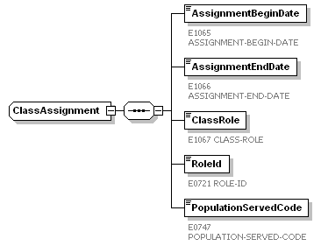

complexType StudentList
diagram | 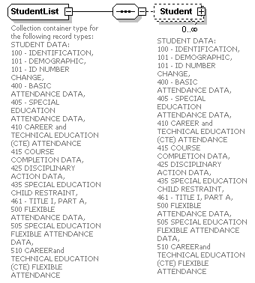

complexType SummerStudent  diagram | 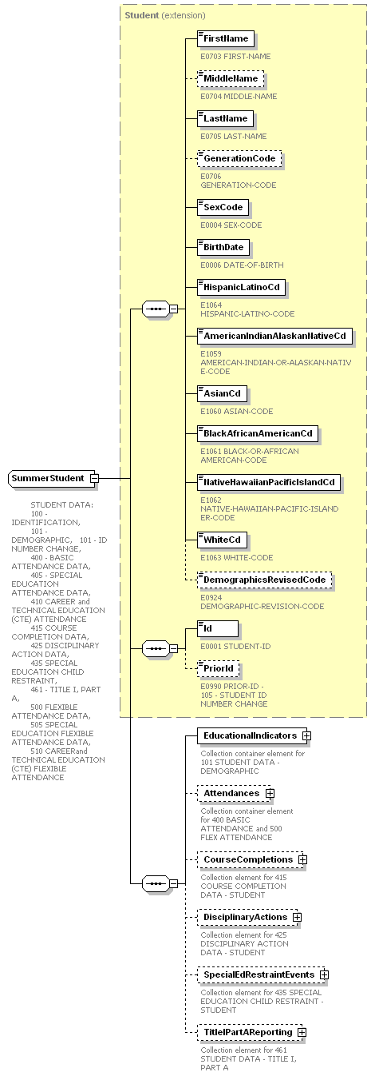

complexType EducationalIndicators
diagram | 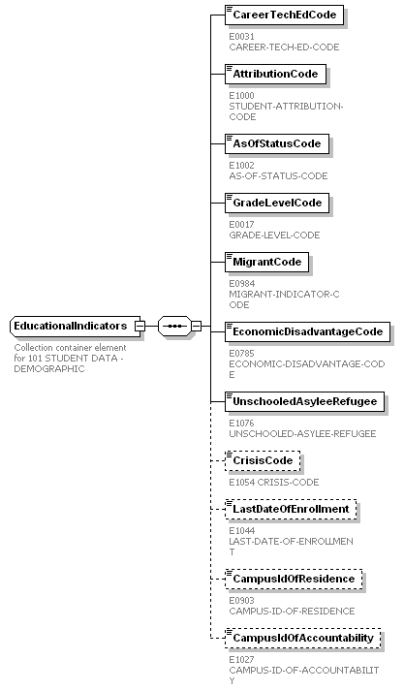

complexType AttendanceList
diagram | 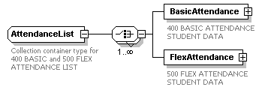

complexType BasicAttendance  diagram | 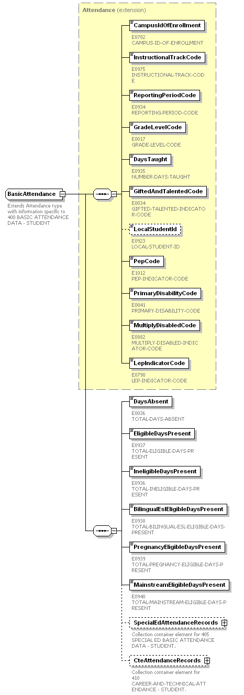

complexType SpecialEdBasicAttendanceList
diagram | 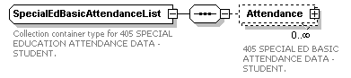

complexType SpecialEdBasicAttendance
diagram | 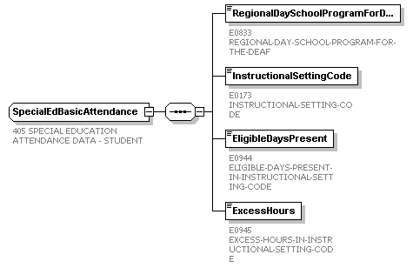

complexType CteAttendanceList
diagram | 

complexType CteAttendance
diagram | 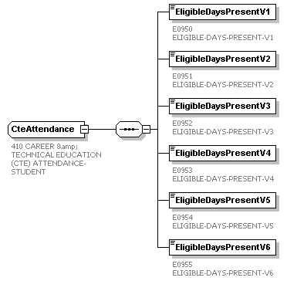

complexType FlexibleAttendance  diagram | 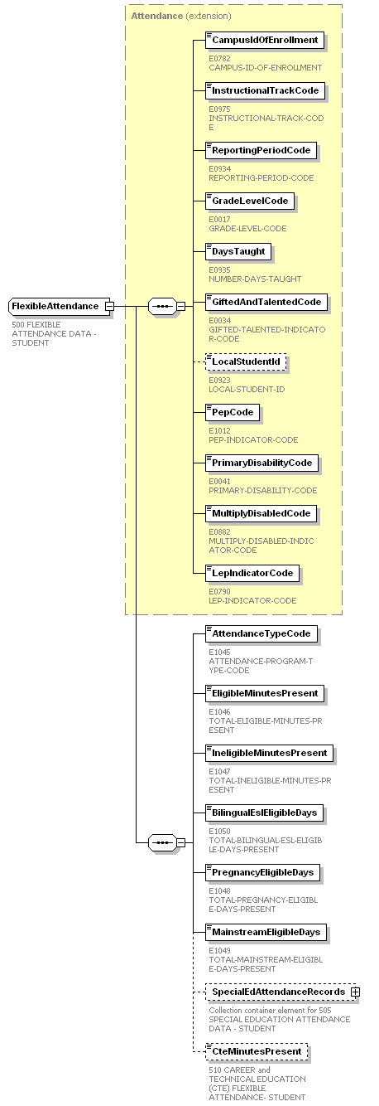

complexType SpecialEdFlexibleAttendanceList
diagram | 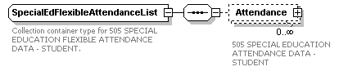

complexType SpecialEdFlexibleAttendance
diagram | 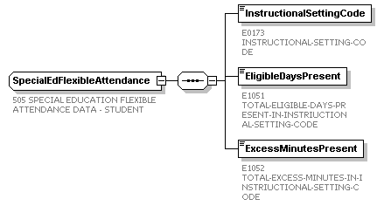

complexType CourseCompletionList
diagram | 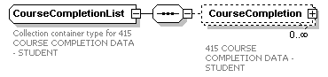

complexType CourseCompletion
diagram | 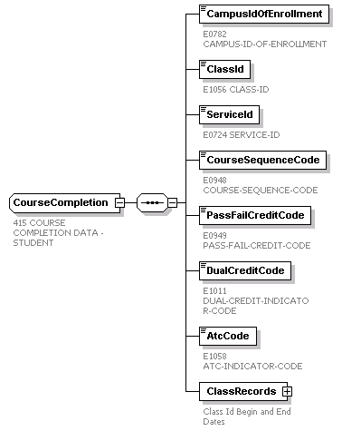

complexType StudentClassList
diagram | 

complexType StudentClass
diagram | 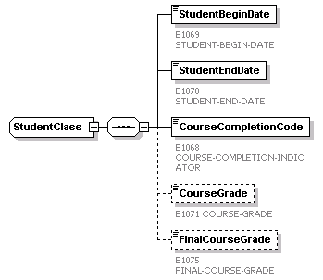

complexType DisciplinaryActionList
diagram | 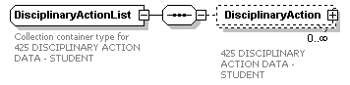
complexType DisciplinaryAction  diagram | 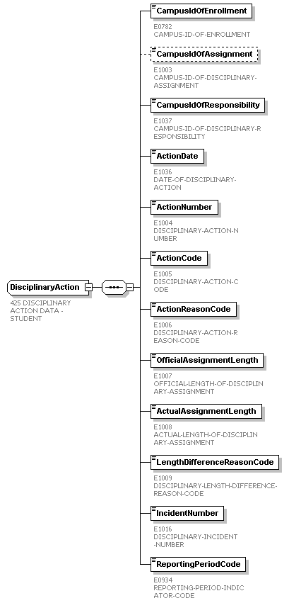

complexType SpecialEdRestraintEventList
diagram | 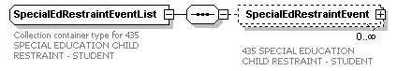

complexType SpecialEdRestraintEvent
diagram | 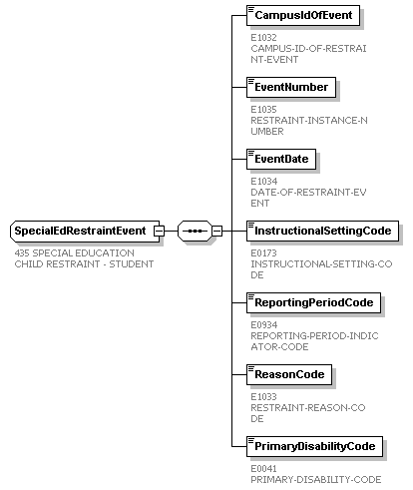

complexType TitleIPartAList
diagram | 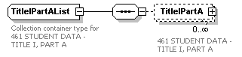

complexType TitleIPartA
diagram | 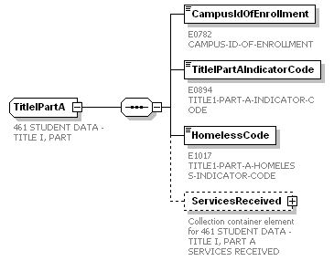

complexType TitleIPartAServices
diagram | 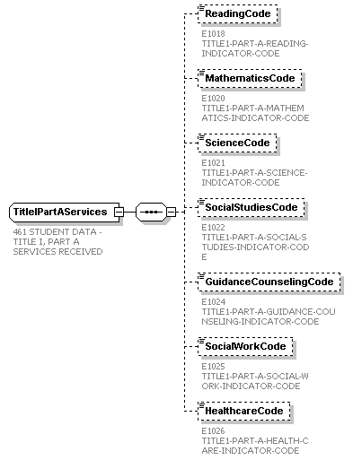

This page is intentionally left blank.
element ExtendedYearDataSubmission
diagram | 

complexType ExtendedYearDistrict
diagram | 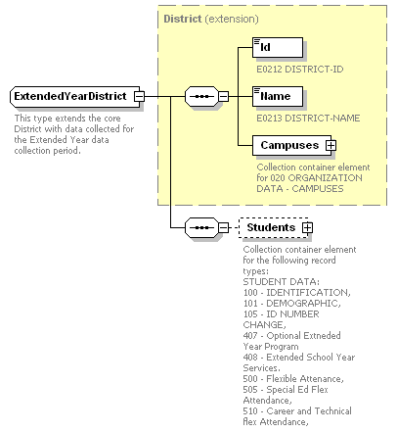

complexType CampusList
- diagram

complexType Campus
diagram

complexType StudentList
diagram | 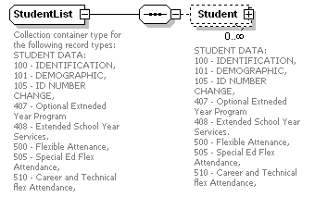

complexType ExtendedYearStudent  diagram | 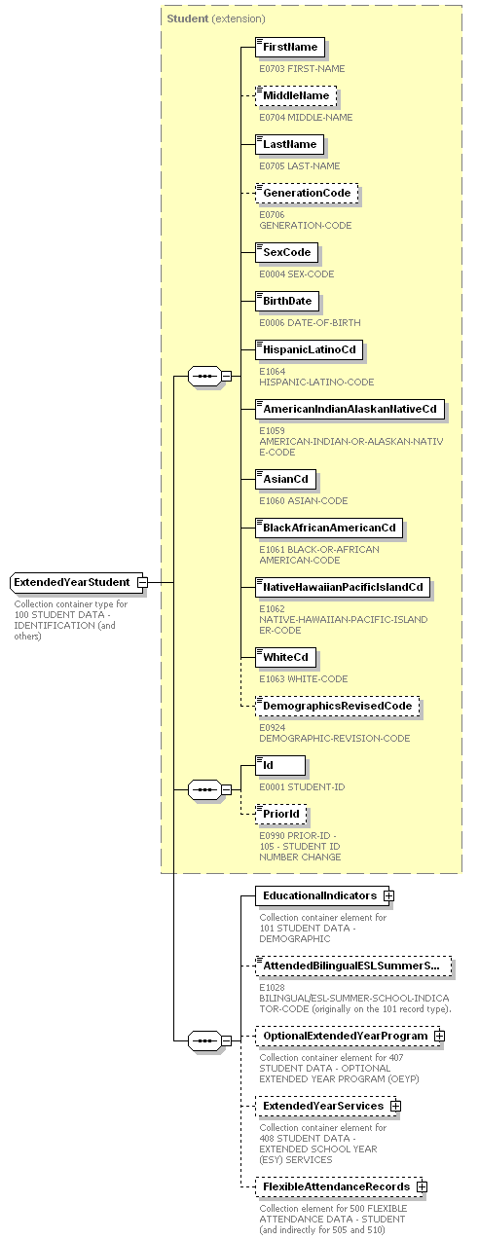
complexType EducationalIndicators
diagram | 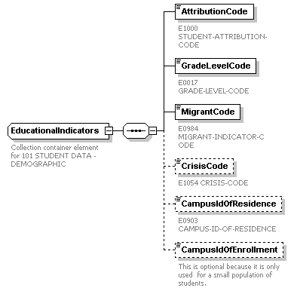

complexType OptionalExtendedYearProgram
diagram | 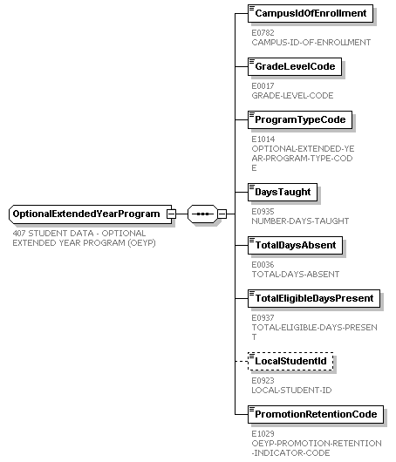

complexType ExtendedYearServiceList
diagram | 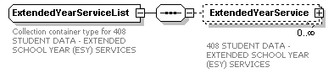

complexType ExtendedYearService
diagram | 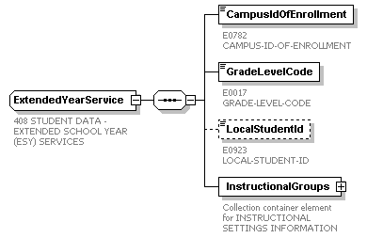

complexType InstructionalGroupList
diagram | 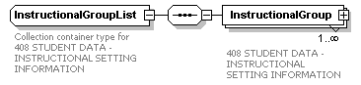

complexType InstructionalGroup
diagram | 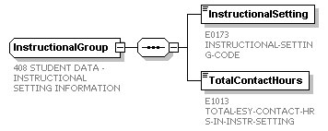

complexType FlexibleAttendanceList
diagram | 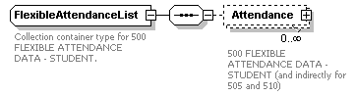

complexType FlexibleAttendance

diagram

complexType SpecialEdFlexibleAttendanceList
diagram | 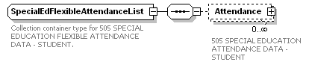

diagram

